File Upload through postman :

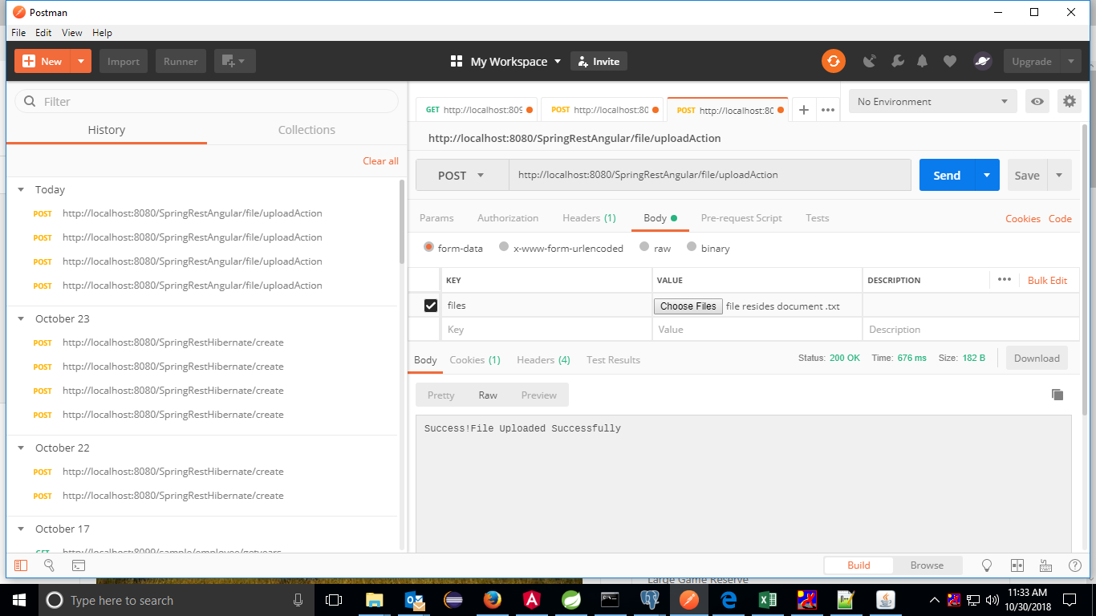

<https://grokonez.com/frontend/angular/angular-4-uploadget-multipartfile-tofrom-spring-boot-server>

Angular refer above link

Choose Body -?Request can be passed through **Key** as Requestparam value mentioned in server as **files** choose any file as **value**

<http://localhost:8080/SpringRestAngular/file/uploadAction>

FileUploadController

package com.srmt.erp.controller;

import java.io.IOException;

import java.nio.file.Files;

import java.nio.file.Path;

import java.nio.file.Paths;

import javax.servlet.ServletContext;

import javax.servlet.http.HttpServletRequest;

import javax.servlet.http.HttpServletResponse;

import org.springframework.beans.factory.annotation.Autowired;

import org.springframework.core.io.ClassPathResource;

import org.springframework.core.io.InputStreamResource;

import org.springframework.http.HttpHeaders;

import org.springframework.http.HttpStatus;

import org.springframework.http.MediaType;

import org.springframework.http.ResponseEntity;

import org.springframework.web.bind.annotation.PathVariable;

import org.springframework.web.bind.annotation.PostMapping;

import org.springframework.web.bind.annotation.RequestMapping;

import org.springframework.web.bind.annotation.RequestMethod;

import org.springframework.web.bind.annotation.RequestParam;

import org.springframework.web.bind.annotation.ResponseBody;

import org.springframework.web.bind.annotation.RestController;

import org.springframework.web.multipart.MultipartFile;

import com.srmt.erp.dao.StudentDAO;

@RestController

@RequestMapping("file")

@javax.servlet.annotation.MultipartConfig

public class FileUploadController {

@Autowired

private StudentDAO studentDao;

@PostMapping("/uploadAction")

public @ResponseBody String handleFileUpload( @RequestParam("files") MultipartFile files) throws IOException{

studentDao.save(files);

return "Success!File Uploaded Successfully";

}

}

studentDao

public void save(MultipartFile fileUpload) throws IOException;

studentDaoImpl

============

@Override

@Transactional

**public** **void** save(MultipartFile fileUpload) **throws** IOException {

UploadFile uf = **new** UploadFile();

uf.setFileName(fileUpload.getOriginalFilename());

uf.setData(fileUpload.getBytes());

//uf.setData(fileUpload.getBytes());

entityManager.persist(uf);

/*UserDocument document = new UserDocument();

MultipartFile multipartFile = fileBucket.getFile();

document.setName(multipartFile.getOriginalFilename());

document.setDescription(fileBucket.getDescription());

document.setType(multipartFile.getContentType());

document.setContent(multipartFile.getBytes());

document.setUser(user);

userDocumentService.saveDocument(document);*/

}

Model ->

**UploadFile .java**

package com.srmt.erp.model;

import java.io.Serializable;

import java.util.Arrays;

import javax.persistence.Column;

import javax.persistence.Entity;

import javax.persistence.GeneratedValue;

import javax.persistence.GenerationType;

import javax.persistence.Id;

import javax.persistence.Lob;

import javax.persistence.Table;

import javax.persistence.*;

@Entity

@Table(name="file")

public class UploadFile implements Serializable {

/**

*

*/

private static final long serialVersionUID = 1L;

@Id

@GeneratedValue(strategy=GenerationType.AUTO)

private Long FILE_ID;

@Column(name="FILE_NAME")

private String fileName;

@Lob

@Column(name = "FILE_DATA", columnDefinition="oid")

private byte[] data;

public UploadFile() {

super();

}

public UploadFile(Long FILE_ID,String fileName,byte[] data) {

this.FILE_ID=FILE_ID;

this.fileName=fileName;

this.data=data;

}

public Long getFILE_ID() {

return FILE_ID;

}

public void setFILE_ID(Long fILE_ID) {

FILE_ID = fILE_ID;

}

public String getFileName() {

return fileName;

}

public void setFileName(String fileName) {

this.fileName = fileName;

}

public byte[] getData() {

return data;

}

public void setData(byte[] data) {

this.data = data;

}

@Override

public String toString() {

return "UploadFile [FILE_ID=" + FILE_ID + ", fileName=" + fileName + ", data=" + Arrays.toString(data) + "]";

}

}